Bài 2.1

Mô phỏng cổng luận lý AND:

|  |  |  |
| --- | --- | --- |
| A | B | F |
| 0 | 0 | 0 |
| 0 | 1 | 0 |
| 1 | 0 | 0 |
| 1 | 1 | 1 |

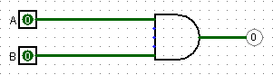

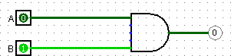

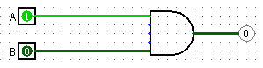

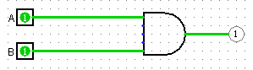

Mô phỏng cổng luận lý OR:

|  |  |  |
| --- | --- | --- |
| A | B | F |
| 0 | 0 | 0 |
| 0 | 1 | 1 |
| 1 | 0 | 1 |
| 1 | 1 | 1 |

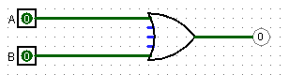

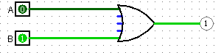

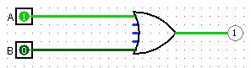

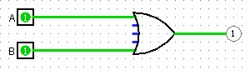

Mô phỏng cổng luận lý NOT:

|  |  |
| --- | --- |
| A | B |
| 0 | 1 |
| 1 | 0 |





Mô phỏng cổng luận lý XOR:

|  |  |  |
| --- | --- | --- |
| A | B | F |
| 0 | 0 | 0 |
| 0 | 1 | 1 |
| 1 | 0 | 1 |
| 1 | 1 | 0 |

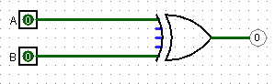

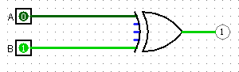

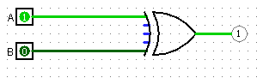

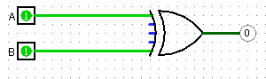Mô phỏng cổng luận lý XNOR:

|  |  |  |
| --- | --- | --- |
| A | B | F |
| 0 | 0 | 1 |
| 0 | 1 | 0 |
| 1 | 0 | 0 |
| 1 | 1 | 1 |

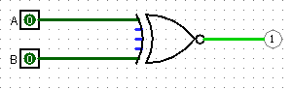

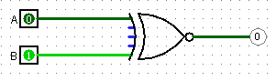

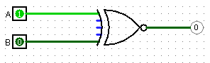

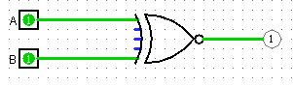

Mô phỏng cổng luận lý NAND:

|  |  |  |
| --- | --- | --- |
| A | B | F |
| 0 | 0 | 1 |
| 0 | 1 | 1 |
| 1 | 0 | 1 |
| 1 | 1 | 0 |

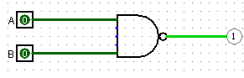

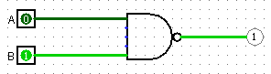

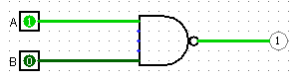

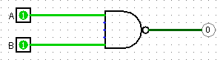

Mô phỏng cổng luận lý NOR:

|  |  |  |
| --- | --- | --- |
| A | B | F |
| 0 | 0 | 1 |
| 0 | 1 | 0 |
| 1 | 0 | 0 |
| 1 | 1 | 0 |

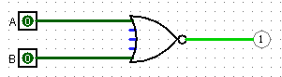

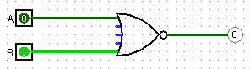

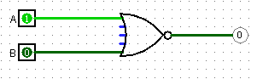

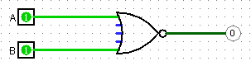

Bài 3.1

|  |  |  |  |
| --- | --- | --- | --- |
| A | B | C | F |
| 0 | 0 | 0 | 0 |
| 0 | 0 | 1 | 1 |
| 0 | 1 | 0 | 0 |
| 0 | 1 | 1 | 1 |
| 1 | 0 | 0 | 0 |
| 1 | 0 | 1 | 1 |
| 1 | 1 | 0 | 1 |
| 1 | 1 | 1 | 1 |

